BACH KHOA UNIVERSITY
OFFICE FOR INTERNATIONAL STUDY PROGRAM
FACULTY OF CIVIL ENGINEERING
---------------o0o---------------

REPORT

STUDY TOUR GRANT
Japanese Society of Civil Engineering (JSCE)

Mr. Mai Hoang Bao
2017 STG Participant
Bach Khoa University, Vietnam

Ho Chi Minh city, Vietnam, 28th September 2017
TABLE OF CONTENT

1. INTRODUCTION 1
1.1 All about JSCE 1
1.2 Objectives of Study Tour Grand(STG) 1
1.3 STG participants 2
2. STUDY TOUR GRAND ACTIVITIES 3
2.1 Itinerary 3
2.2 The 1st day (10th September) 4
2.3 The 2nd day (11th September) 4
2.4 The 3rd day (12th September) 6
2.5 The 4th day (13th September) 10
2.6 The 5th day (14th September) 14
2.7 The 6th day (15th September) 20
2.7 The 7th day (16th September) 23
3. GRATITUDE AND ACCOMPLISHMENT 23

1. INTRODUCTION

1.1 All about JSCE
Japan Society of Civil Engineers (JSCE) was established as an incorporated association in 1914 with the mission to contribute to the advancement of scientific culture by promoting the field of civil engineering and the expansion of civil engineering activities. Over the years, the JSCE membership has increased significantly from the initial 443 members to approximately 39,000 members at present, and is currently engaged in various wide-ranged activities around the world.
With the birth of the 21st century, It has reconfirmed its goals to exert perpetual efforts
1. To propose an idea for social infrastructure development in the future from the civil engineer’s perspective
2. To acquire a steadfast relationship of mutual trust with the society,
3. To promote scientific and technological researches/studies with a high degree of transparency,
4. To evaluate public works from a neutral standpoint, and to reach a social consensus on those proper standards.
Furthermore, JSCE will implement such new indispensable programs as Civil Engineers' Qualification System, Continuing Professional Development, etc., for the benefit of creating an environment where civil engineers can widely take on an active role in the international community, and where civil engineering technologies may contribute to the amenity of the people both in and outside of Japan.

1.2 Objectives of Study Tour Grand (STG)
JSCE Study Tour Grant (STG), supported by the International Scientific Exchange Fund (ISEF), is a unique program for young civil engineers to learn Japanese civil engineering technology and projects. The STG program invites the civil engineering students who are nominated by the AOC societies in Japan to stay for about one week. During their stay, those students visit project sites and research institutes, meet leading civil engineering professionals and academics, and share their projects with other students. At the end of the program they are requested to submit a report on their experience gained in Japan to JSCE and also to the AOC to which they belong home. This program gives a chance not only to see technological innovations, but also to experience them in the environment that they are achieved.

1.3 STG 2017 participants:
Totally, there are 6 participants from different countries in STG 2017:
- Mr. Mai Hoang Bao from Ho Chi Minh University of Technology, Vietnam.
- Mr. Ganzorig Tsevelsuren from MACE, Mongolia.
- Mr. Pau Sian Muan from MES, Thailand.
- Ms. Tugce Ceran from JSCE Turkey Section, Turkey.
- Mr. Al-Adzhar P. Usman from PICE, Philippines.
- Mr. Pornnarong Lueanpech from JSCE Thailand Section.

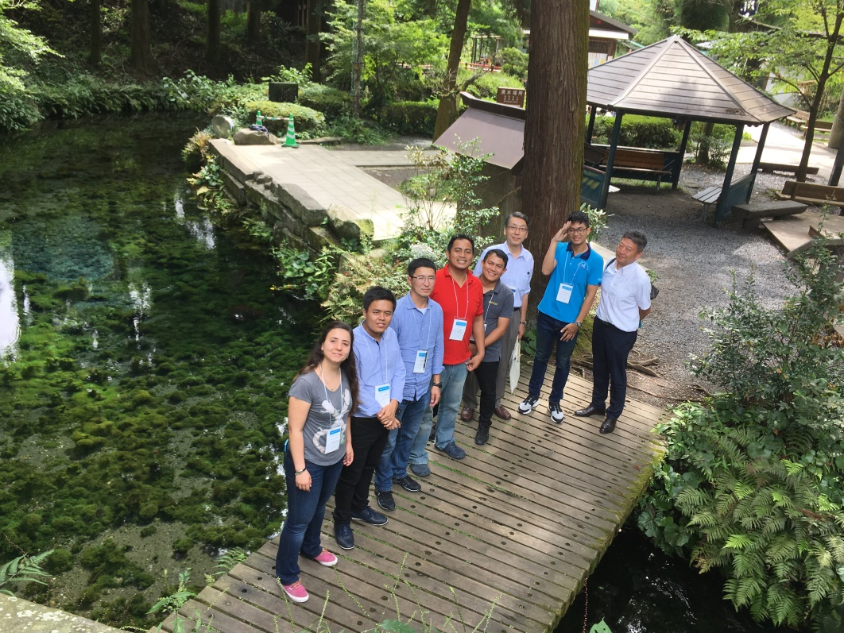
Figure 1 STG participants with Mr. Yoshizawa, Mr. Katayama

2. STUDY TOUR GRAND ACTIVITIES

2.1 Itinerary
Main schedule of STG 2017: Sep. 10th(Sun) – Sep. 16th(Sat)
 | Date | Time | Event | Attend
1 | 9/10, Sun | - | Arrive at Narita Airport  Check in NISHITETSU INN Shinjuku | Ms. Suzuki
2 | 9/11, Mon | 8:30 ~ 11:30 | Visit KAJIMA Technical Research Institute | Ms. Suzuki, Mr. Yoshizawa
 |  | 15:00 ~ 16:45 | Leave HANEDA Airport for FUKUOKA Airport by Flight ANA634 | Ms. Suzuki, Mr. Yoshizawa
 |  | 17:30 ~ 19:30 | Attend the JSCE Networking reception at “Big Sand” | Ms. Suzuki, Mr. Yoshizawa
 |  | 19:30 | Go to NISHITETSU Grand Hotel | Ms. Suzuki, Mr. Yoshizawa, Mr. Katayama
3 | 9/12, Tue | 9:00 ~ 12:00 | Participate and deliver a presentation at the 19th International Summer Symposium (Kyushu University) | Ms. Suzuki, Mr. Yoshizawa, Mr. Katayama
 |  | 13:00 ~ 16:00 | Go to project site: Yabegawa Bridge, Yabe-river levee breakdown site, Miike Coal Mine Site | Ms. Suzuki, Mr. Yoshizawa, Mr. Katayama, Ms. Ito
 |  | 18:00 | Check in HOTEL ROUTEINN KUMAMOTO EKIMAE | Ms. Suzuki, Mr. Yoshizawa, Mr. Katayama
4 | 9/13, Wed | 9:00 ~ 15:05 | Visit Kumamoto earthquake disaster affected sites | Ms. Suzuki, Mr. Yoshizawa, Mr. Katayama
 |  | 17:25 ~ 19:00 | Leave KUMAMOTO Airport for HANEDA Airport by Flight JAL634 | Ms. Suzuki, Mr. Yoshizawa, Mr. Katayama
 |  | 20:00 | Check in Hotel KEIO PRESSO INN | Ms. Suzuki
5 | 9/14, Thu | 9:30 ~ 12:00 | Tokyo_Gaikan Expressway: “TAJIRI-Area Project” | Ms. Suzuki, Mr. Sakata
 |  | 13:00 ~ 15:00 | Visit SHIMIZU Institute of Technology | Ms. Suzuki, Mr. Katama, Ms. Shibuya, Mr. Arai
 |  | 15:30 ~ 17:00 | Visit JR Tokyo Station Site | Ms. Suzuki, Mr. Asano,  Ms. Shibuya, Mr. Arai
 |  | 18:30 ~ 20:30 | Dinner with ISEF Committee Members | Ms. Suzuki, Mr. Yoshizawa, Mr. Katayama,  Ms. Shibuya, Mr. Arai
 |  | 21:00 | Back to hotel
6 | 9/15, Fri | ~ 12:00 | Free time
 |  | 12:30 ~ 17:00 | Go on sightseeing in Tokyo | Ms. Suzuki, Mr. Arai
 |  | 20:00 | Back to hotel
7 | 9/16, Sat | - | Check out the hotel and go to Narita International Airport | Ms. Suzuki

2.1 The 1st day (10th September)
My flight from Tan Son Nhat International Airport to Narita Airport landed at 3pm. After completing all immigration procedure, I took an airport bus and arrived NISHITETSU INN Shinjuku hotel at 18h30. Ms. Suzuki warmly welcomed and she helped me to check in the hotel. After that, me and Mr. Al-Adzhar P. Usman had dinner together and prepared for the next day.
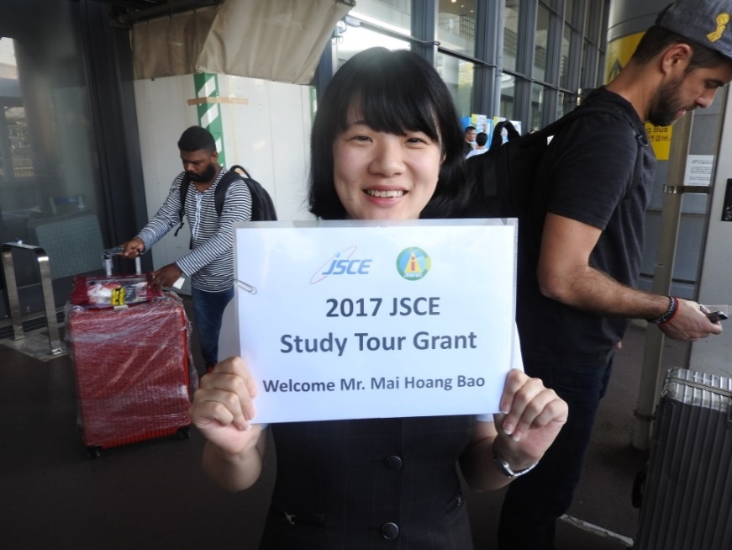
Figure 2 Arriving Narita Airport

2.2 The 2nd day (11th September)
At 7h30, we checked-out the hotel and started going to our first stop. On the bus, we received a detailed itinerary and discussed some information about our program.
At 8h15, we arrived at KAJIMA Technical Research Institute and received a warm greeting from Mr. Yoshizawa. After introducing ourselves and listening to Mr. Yoshizawa presenting about KAJIMA Corporation, we visited some laboratories:
- Skaking Table Laboratory
- Structural Laboratory
- Concrete and Wind-Tunnel Laboratory
- Construction and Fire Safety Laboratory
In these laboratories, we learned new innovative technology and testing procedure in regard to 4 aspects: civil engineering, disaster prevention, building science, environmental consideration. Among these laboratories, I was really impressed by the shaking table laboratory. It has 2 tables (large table 35m², max displacement 70cm; small table 4m², max displacement 2.7m) to simulate earthquakes and therefore examining the behaviors of the structure under the earthquakes.
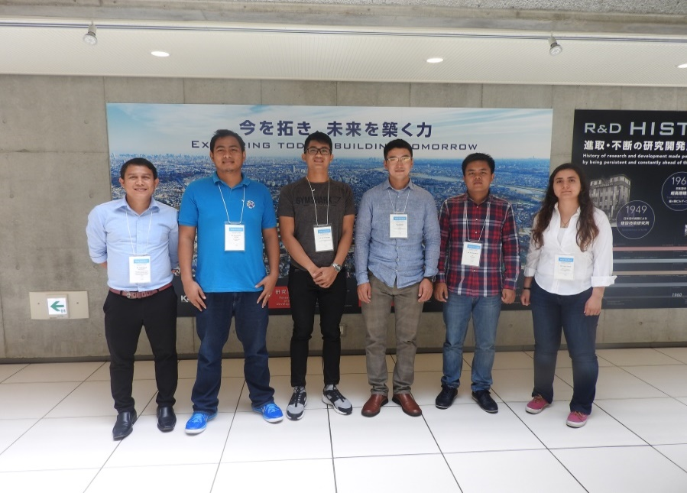
Figure 3 STG Participants at Kajima Corporation

After finishing the laboratory tour, we had lunch and went to HANEDA airport to go to Fukuoka. Mr. Yoshizawa also joined us. When we arrived Fukuoka, we attended JSCE Networking Reception at Kyushu University. We were greeted by JSCE members and had a delicious dinner together. In this meeting, I was happy to meet my advisor Dr. Mikio Ishiwatari, we had a small discussion about my trip and also my presentation tomorrow. After the meeting, we took a bus at “BIG ORANGE” and went to NISHITETSU Grand Hotel. At night, I prepared for my presentation at 19th Summer Symposium tomorrow.
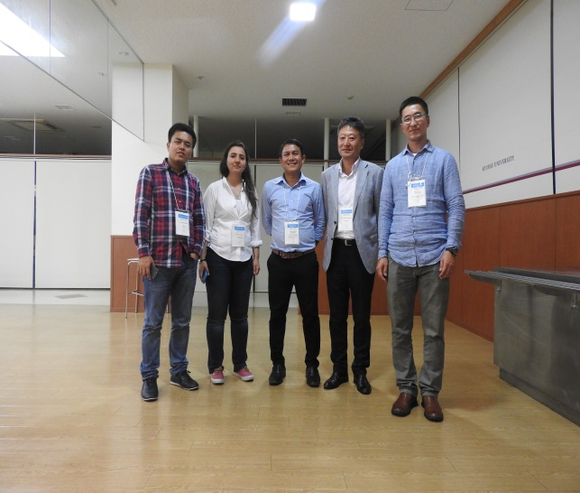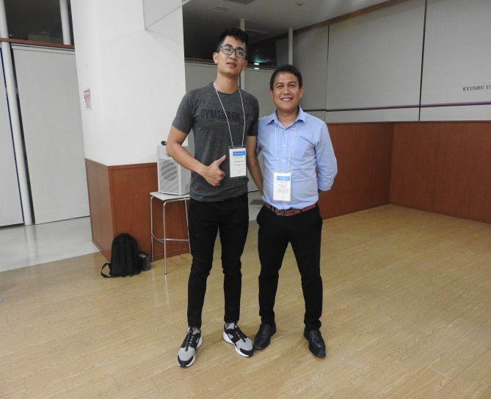
Figure 4, 5 STG Participants at JSCE Networking Reception

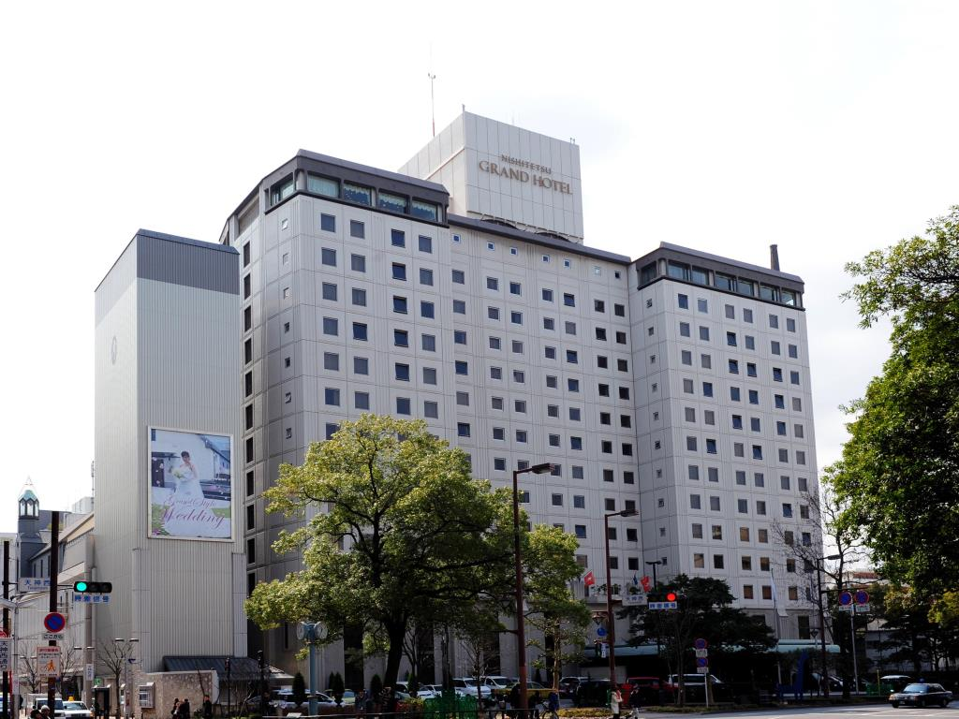
Figure 6 NISHITETSU Grand Hotel

2.3 The 3rd day (12th September)
In the morning, we went to Kyushu University by charter bus and attended the 19th International Summer Symposium. We were greeted by Mr. Katayama and prepared for our presentations at Open Learning Plaza Lecture Room 5 & 6. This was my first time ever to present a research at the International Conference like this, hence I feel extremely nervous. During the 19th International Summer Symposium, I attentively listened to other presentations of many scientific projects and I really interested at some project like “Concrete Recycling”, “Shear behavior for RC Tapered beams with stirrups”, “Internationalization: recommendations for Japanese construction firms”.
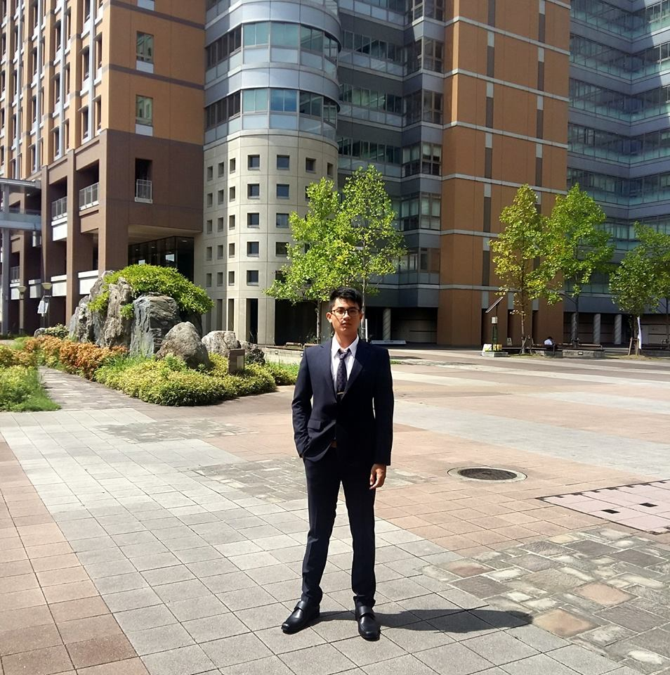
Figure 7 At Kyushu University

At 11:30, I presented my research: “Traffic congestion in Ho Chi Minh city under the view of young civil engineering” and it was one of the my greatest moment of STG. In this presentation, I revealed the whole scenario of traffic in Ho Chi Minh city:
- The reality of traffic jams in Ho Chi Minh city: happen daily and heavily.
- The causes of congestion: the supply (traffic infrastructure) cannot satisfy the demand (vehicles).
- The government solutions: Mass Rapid Transit (MRT) includes The Metro (main project); Bus Rapid Transit (BRT), tramway, elevated roads, monorail (satellite projects).
- The innovative solutions: Anti-traffic jams application, Traffic light simulation software, Bosch eScooter and some management solutions.
My speech was successfully delivered and this was one of my greatest moment in this Study Tour Grand. The 19th International Summer Symposium gave me a rare opportunity to gain lots of valuable experience, knowledge and communication, presentation skills.
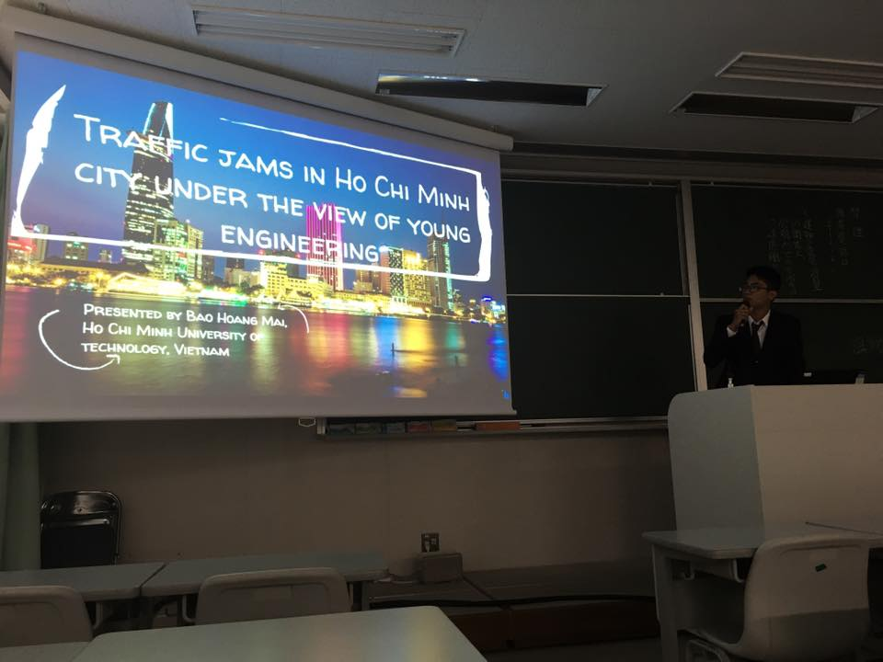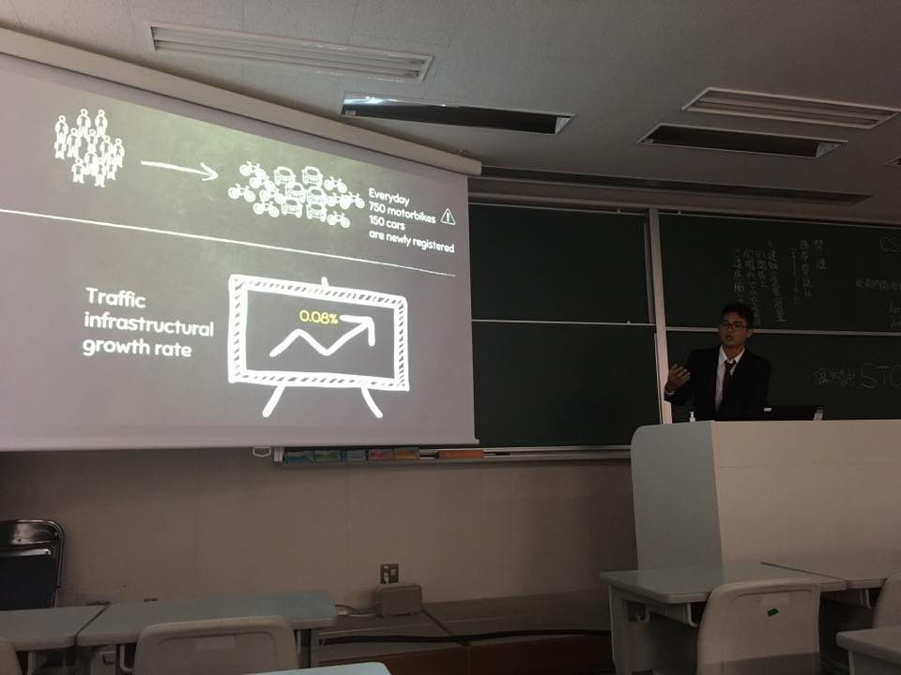
Figure 8, 9 My presentation at the 19th International Summer Symposium

After having lunch, we went to Project sites by charter bus and visited:
- Yabegawa Bridge: This is the largest Span Prestressed Concrete Cabl Stayed Bridge within Japan using Innovative Technology to lower the cost and enhance the strength of the bridge.
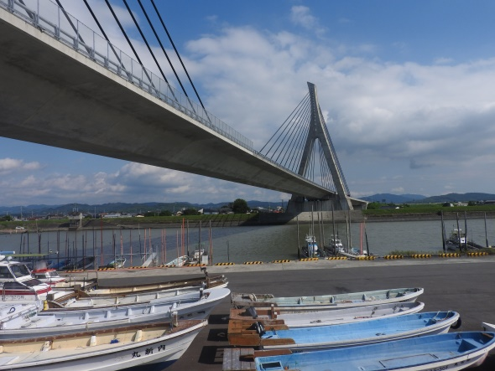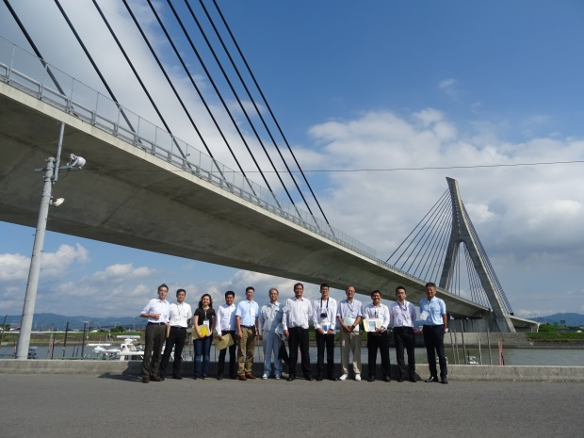
Figure 10, 11 Yabegawa Bridge

- Yabe-river levee breakdown site
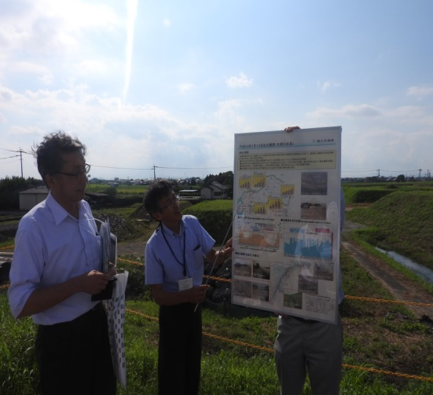 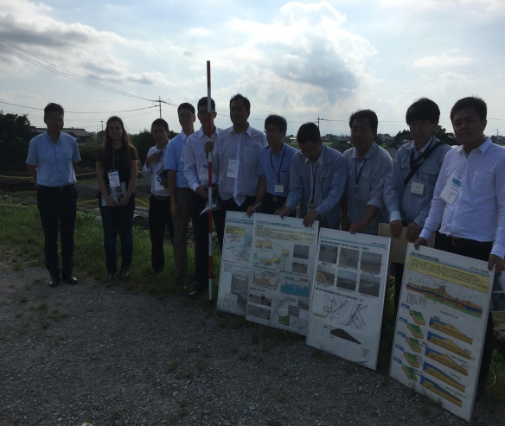
Figure 12 Demonstration Figure 13 Group photo

- Miike coal mine site: the mining began during the Kyoho era. The mine was nationalized in 1872 by the Meiji government. The Mitsui Zaibatsu took control in 1899. The mine closed in 1997, with devastating effects on the local economy.
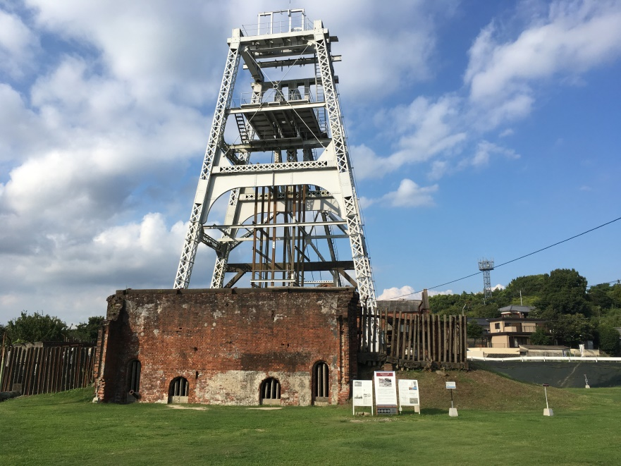
Figure 14 Miike coal mine

At the end of the day, we had dinner and checked in HOTEL ROUTE INN KUMAMOTO EKIMEA.

2.4 The 4th day (13th September)
On this day, our tour was to Kumamoto earthquake disaster affected sites.
Firstly, we came to the Kumamoto Castle Site to witness the damage of the earthquake to the castle and I was really impressed because of repairing process. People collected the collapsed stone and numbered the it in order to place it back into the initial position.
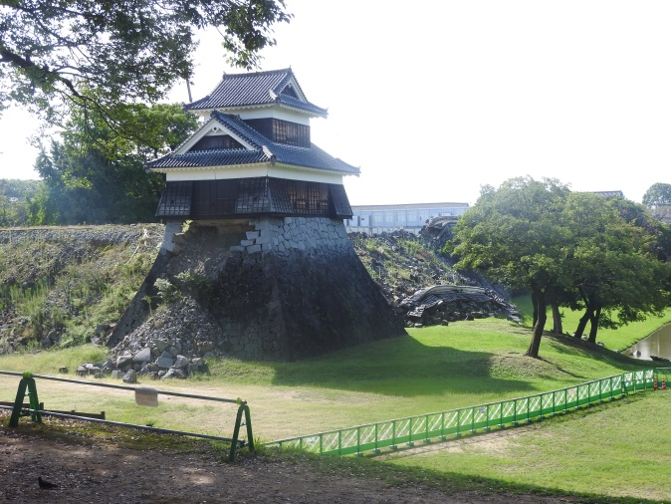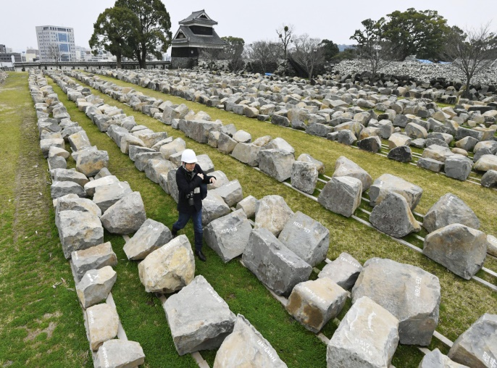
Figure 14 Kumamoto castle collapse Figure 15 Stone field

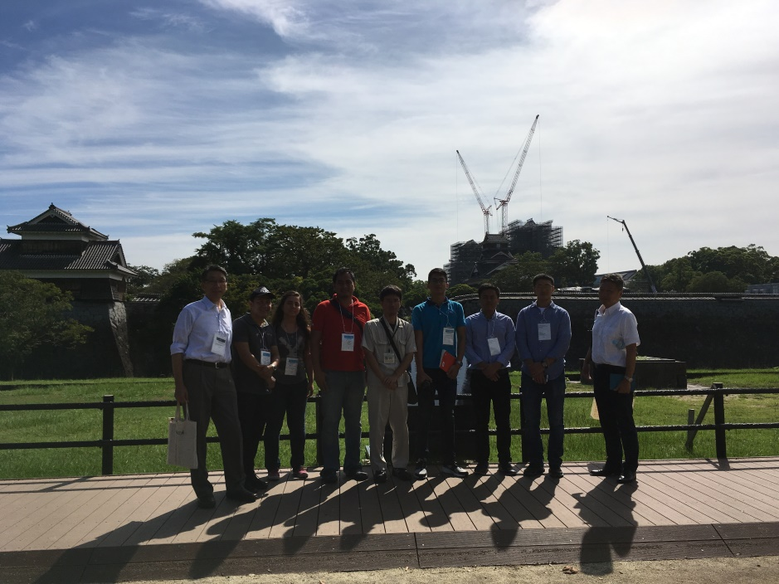
Figure 16 Group photo at Kumamoto castle

Next, we visited Tsujun Bridge, which is the largest stone aqueduct in Japan.
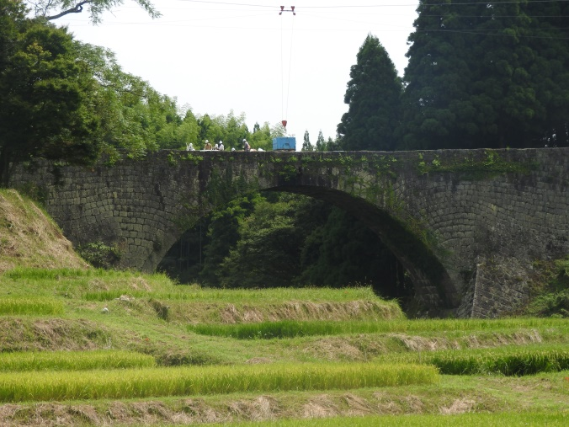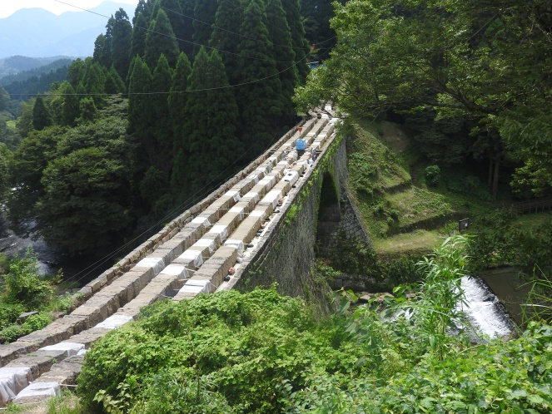
Figure 17, 18 Tsujun Bridge (front view and top view)

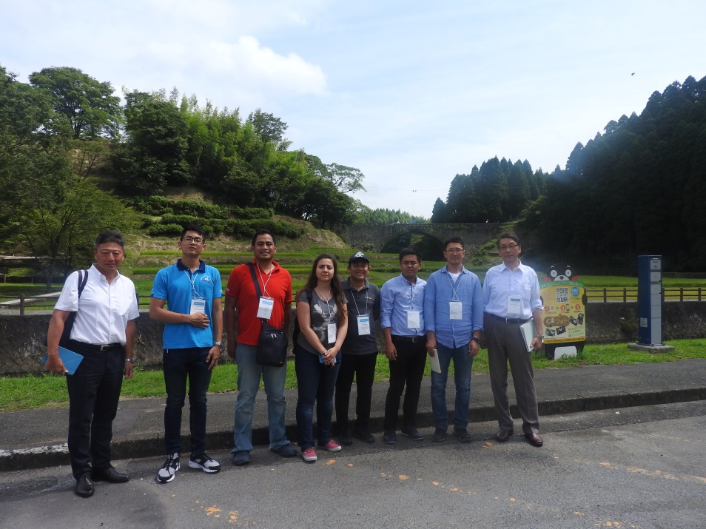
Figure 19 STG Participants with Mr. Yoshizawa and Mr. Katayama at Tsujun Bridge

In the afternoon, we went to Aso Bridge Area Sabo Works. This area was heavily destroyed by the Kumamoto Earthquake in 2016. In particular, one major landslide cuts both national route 57 and the Houhi rail line, either of which is important as a transport link between Kumamoto prefecture and Oita prefecture. Moreover, Aso’s bridge on national route 325 also collapsed. As the first step toward rapid recovery and restoration of the damaged section, the MLIT began urgent work to reverse and control the resulting erosion. Because of the dangerous working conditions, this has been done with heavy unmanned construction machinery (control by engineers in the remote control room nearby). The restoration work includes:
- The installation of earth retaining bank (23 May 2016 – 22 October 2016)
- Rounding (31 August 2016 – 10 November)
- Manned work was started on the lower slope from January 2017. Permanent countermeasures will start on the lower slopes to securing the emergency recovery measures.
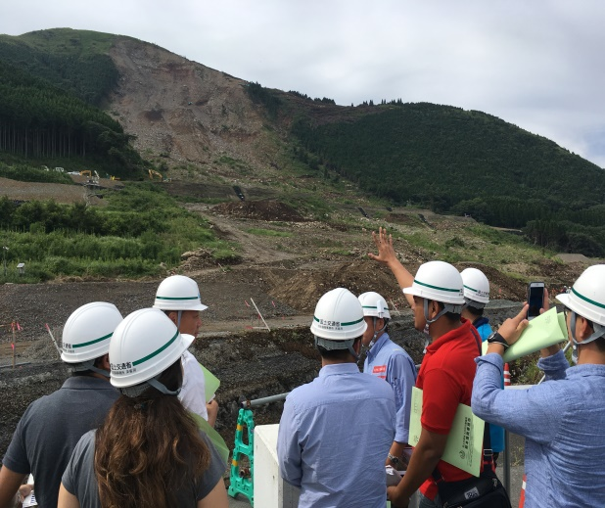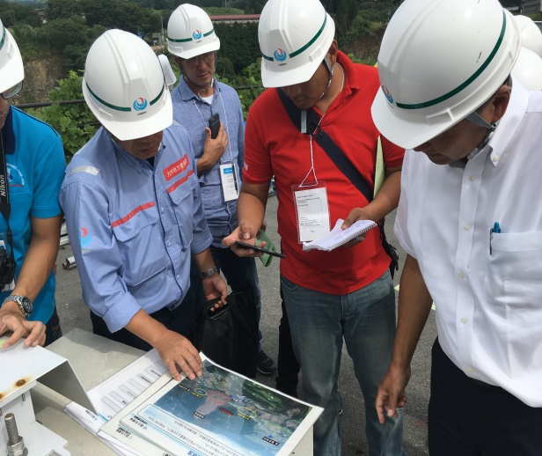
Figure 20, 21 The Aso Bridge Area Sabo Works

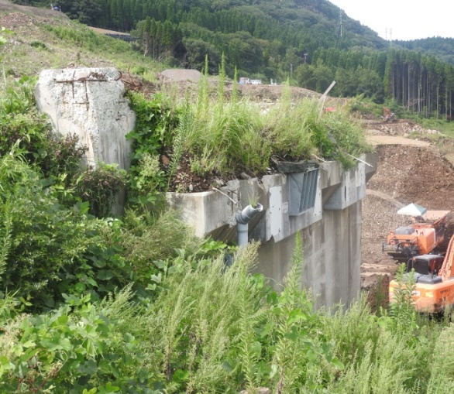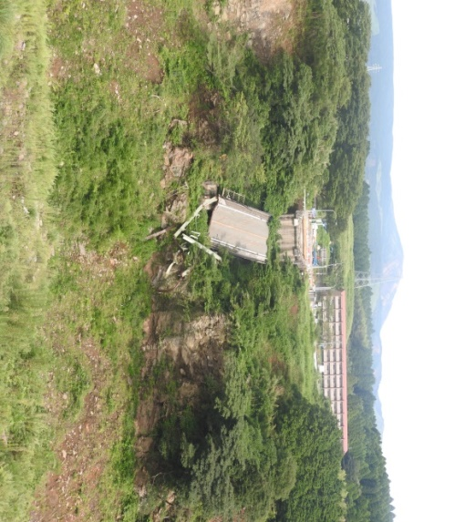
Figure 22, 23 The collapse of Aso Bridge

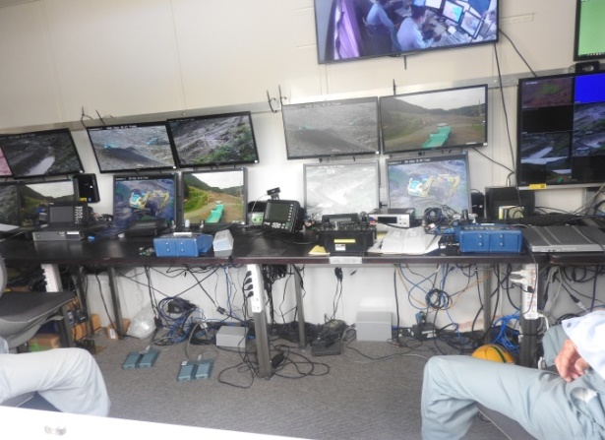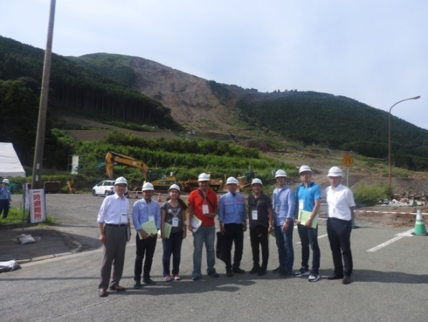
Figure 24 Inside remote control room Figure 25 Group photo

In the evening, we left KUMAMOTO Airport to HANEDA Airport by Flight JAL634 and checked in at Hotel KEIO PRESSO INN Otemachi in Tokyo. At night, I had my first time ever to travel by subway. Me, Mr. Pau and Mr. Pornnaring went from Kanda to Akihabara station and had dinner at a sushi shop. After that, we checked out some souvenir store and got back to the hotel for rest.
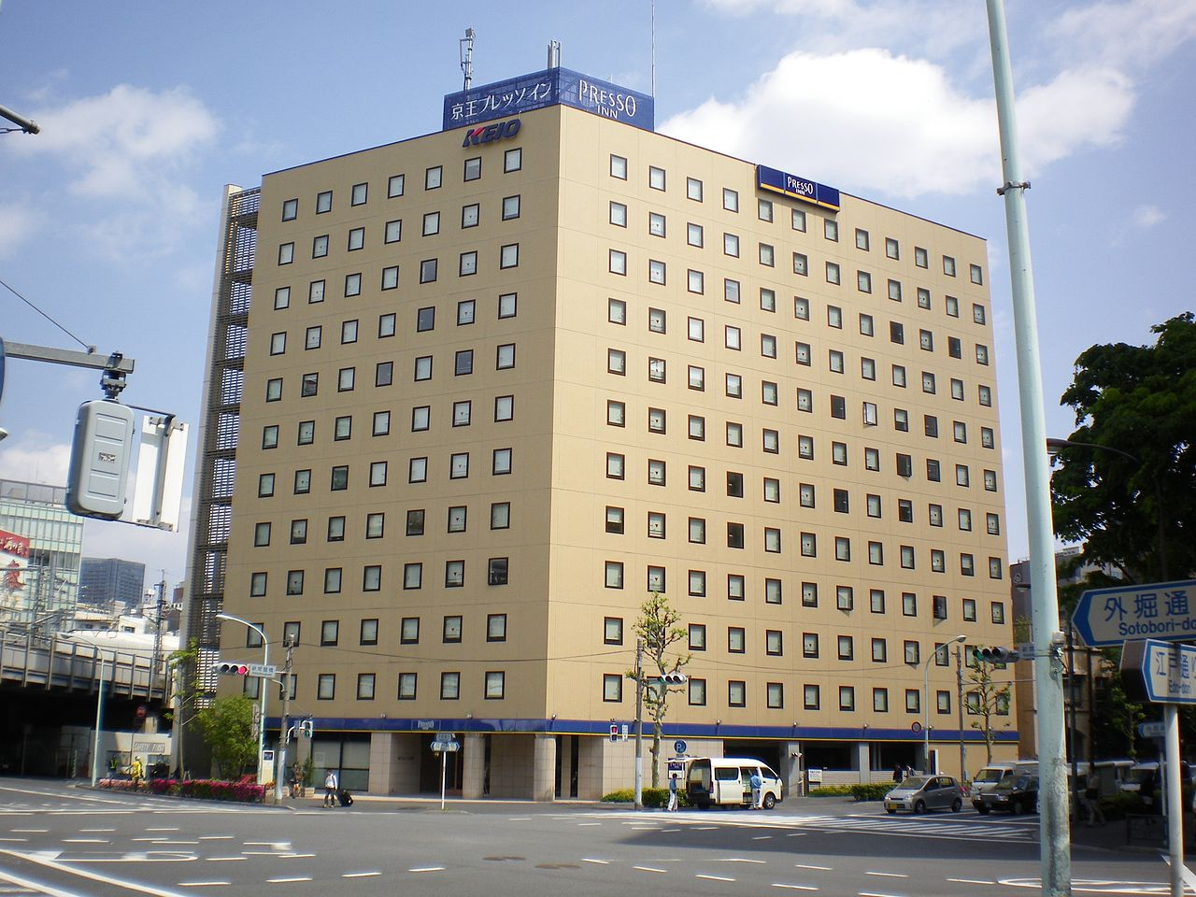
Figure 26 Hotel KEIO PRESSO INN Otemachi

2.5 The 5th day (14th September)
In our last busy day, we visited Tokyo-Gaikan Expressway “TAJIRI-Area Project”. Mr. Sakata from TAISEI Corporation introduced about the project and took us to the construction field to give us more detailed information. Generally, Tajiri area construction site is the work to construct Keiyo-Junction, connecting Tokyo-Gaikan Expressway and Keiyo-Road way. Gaikan-Expressway and Keiyo-Jct ramp are semi-basement the structure. We were really impressed because of the scale and applied technology. In the construction field, we witnessed the under-construction, underground highway and learned about the construction steps (6 main steps).
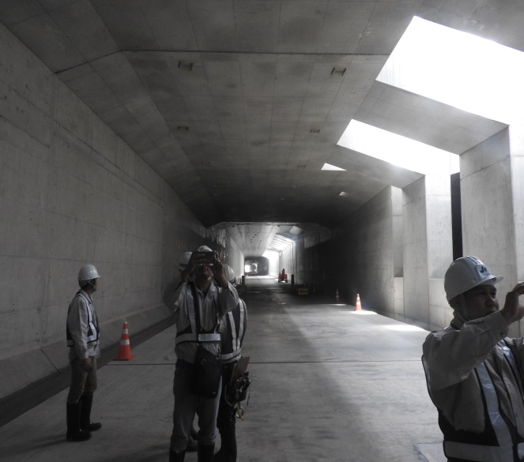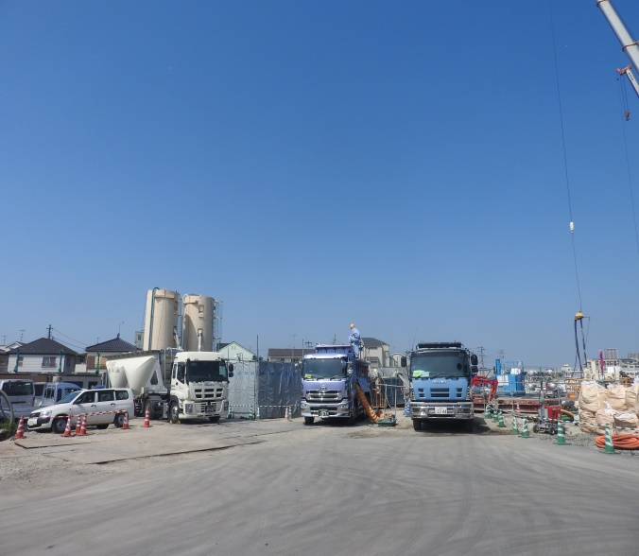
Figure 27, 28 TAJIRI-Area Project

Also, some models were made to simulate the project and though these models, I was able to understand more deeply about the project (Cut and Cover method; Tunneling method). After this field trip, we had lunch, said goodbye to Mr. Sakata and went to SHIMIZU Institute of Technology.
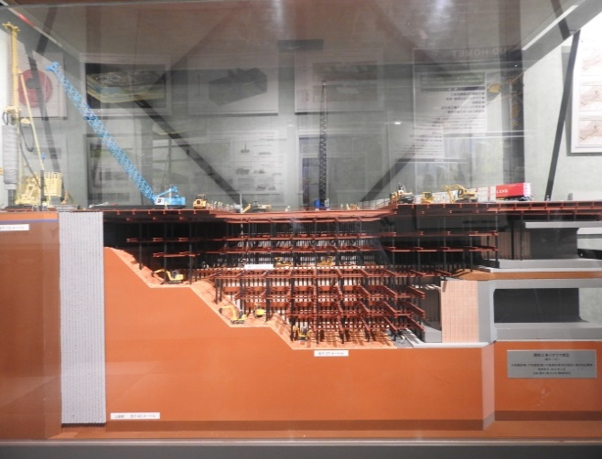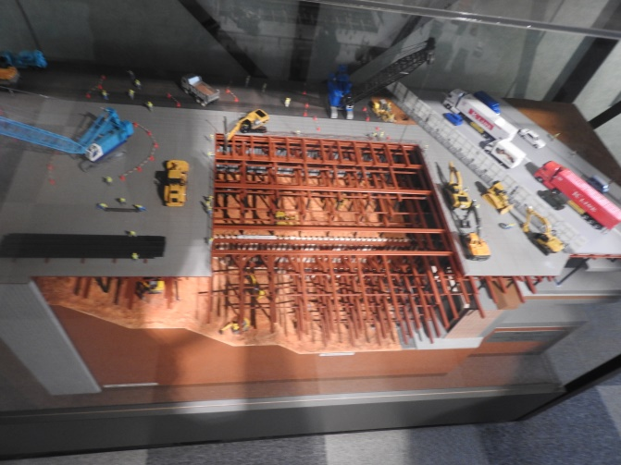
Figure 29, 30 Project model (front view and top view)

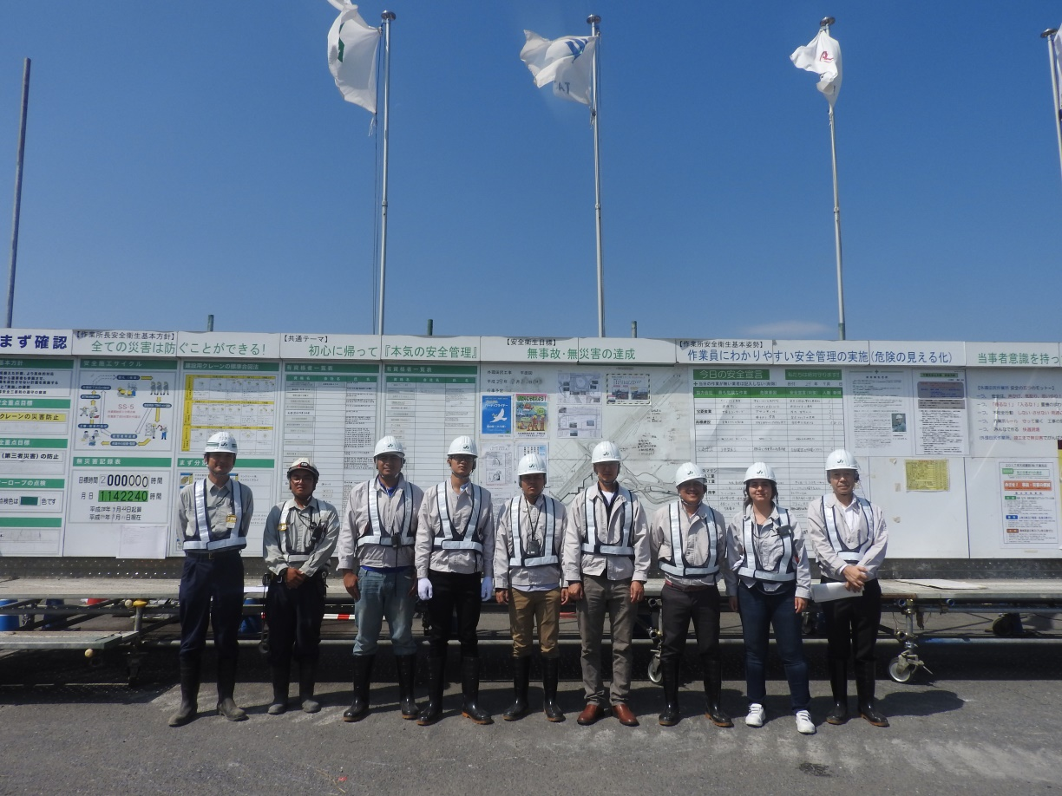
Figure 31 Going to “TAJIRI-Area Project” construction field

At SHIMIZU Institute of Technology, Ms. Shibuya and Mr. Arai from JSCE also joined with us. Firstly, Mr. Katama introduced about the SHIMIZU Corporation. After that, he showed us the construction models which had been constructed by SHIMIZU from the very beginning up to now. To be honest, I was really impressed because there were lots of iconic buildings with a wide range of sizes and unique structures. Then, we visited some other laboratories:
- Fire Testing Block
- Wind Tunnel Testing Laboratory: the examine building with sensors inside was designed together with the surrounding area in a circular model. The model then would be placed in the wind tunnel to test for the wind load and its effect to the surrounding area.
- Seismic Isolation Floor: 2 thin steel plates sliding mechanism significantly reduce saking and protects equipment and maintains room function. Also, we were able to witness the different between “Conventional Earthquake Resistant Design”, Seismic Isolation Method and Response Control Method.
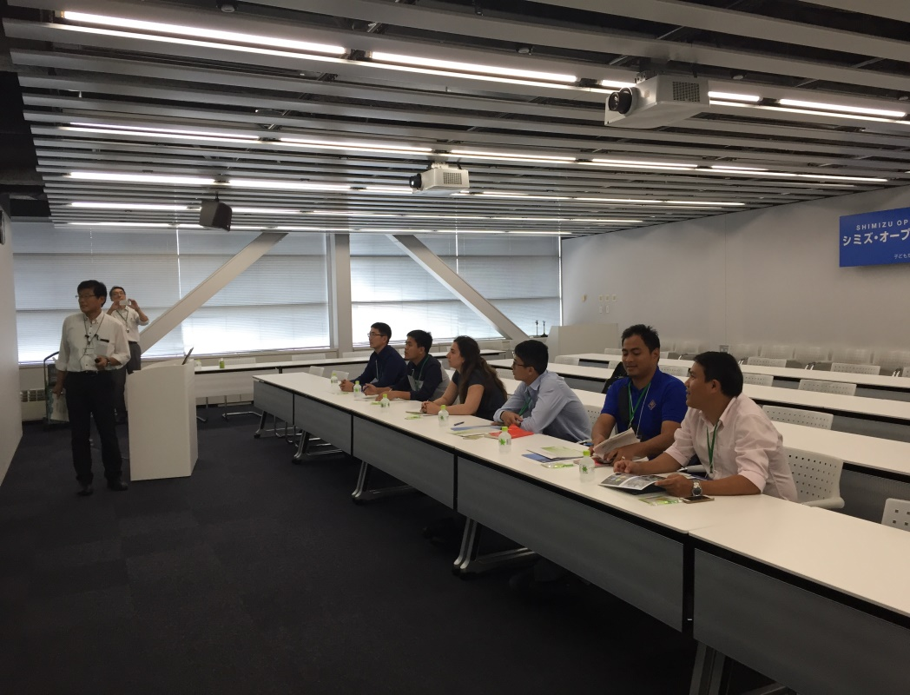
Figure 32 Mr. Katama introduced SHIMIZU Institute of Technology

After that, Mr. Kamata demonstrated the innovative technology using Main Building. This building was a “Column-Top Isolation System”. The upper structure is supported on isolators on independent columns. Next to The Main Building is The Safety and Security Center which was applied “Cor-suspended Isolation System” technology. A seismic isolation mechanism composed of a double layer of inclined rubber bearing was installed on top of the core structure. This building really attracts me because I felt like the whole system was hung using high-strength steel rods, hence it could be placed over other structures like roads. To sum up, this trip to SHIMIZU Institute of Technology really was the best destination of the day, giving me lots of ideas and interest, especially with Seismic Isolation.
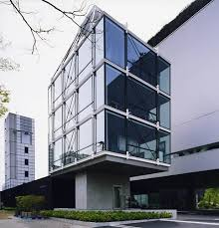
Figure 33 The Safety and Security Center

At 15:00, we leave SHIMIZU Institute of Technology for JR Tokyo Station Site. Mr. Asano introduced Obayashi Corporation and led us to the construction field at Tokyo Station Site. It was a great experience to witness the under-construction project with huge scale like this. We finished our field trip at 17:00 and returned to the hotel to prepare for dinner.
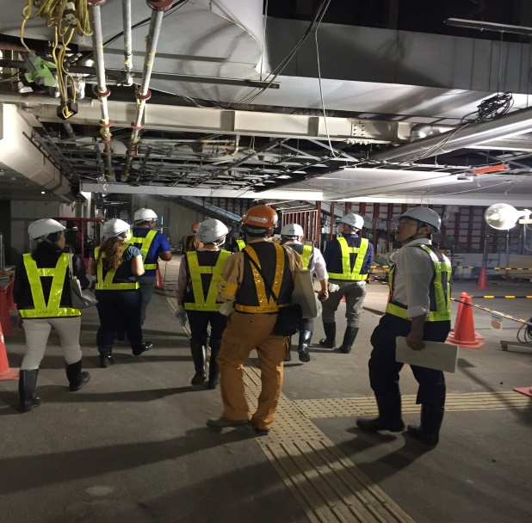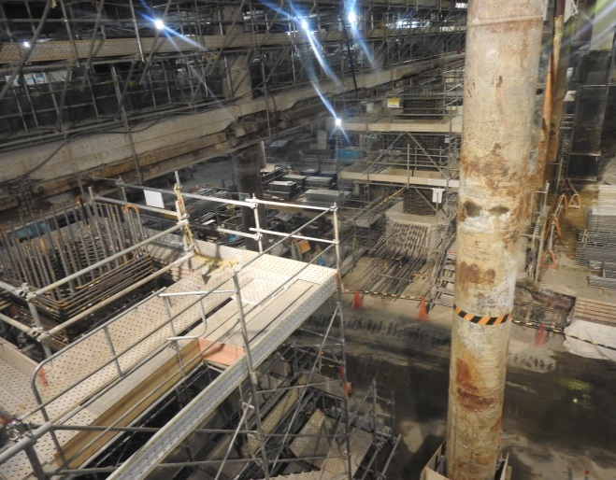
Figure 34 Field trip Figure 35 JR Tokyo Station Site

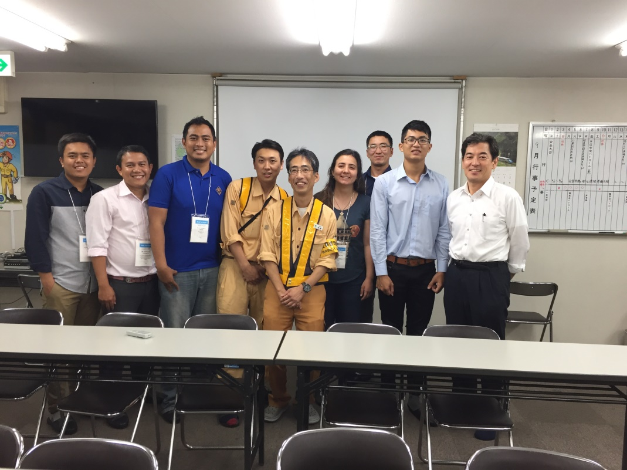
Figure 36 Group photos with Obayashi civil engineers

After having a hard day, we had dinner together at “Budo no mori – Godanya” with ISEF Committee Members. This was our last meeting with Mr. Yoshizawa, Mr. Sakata, Mr. Katayama, Ms. Shibuya and Mr. Arai. We had a superb delicious meal and I loved it. During our dinner, I had a conversation with Ms. Shibuya and I really enjoy talking with her. Throughout the dinner, I understood more about the purpose of this trip and also the purpose of being a civil engineer. To be honest, the dinner was really fun and enjoyable, we shared our stories and widened our understanding about other countries.
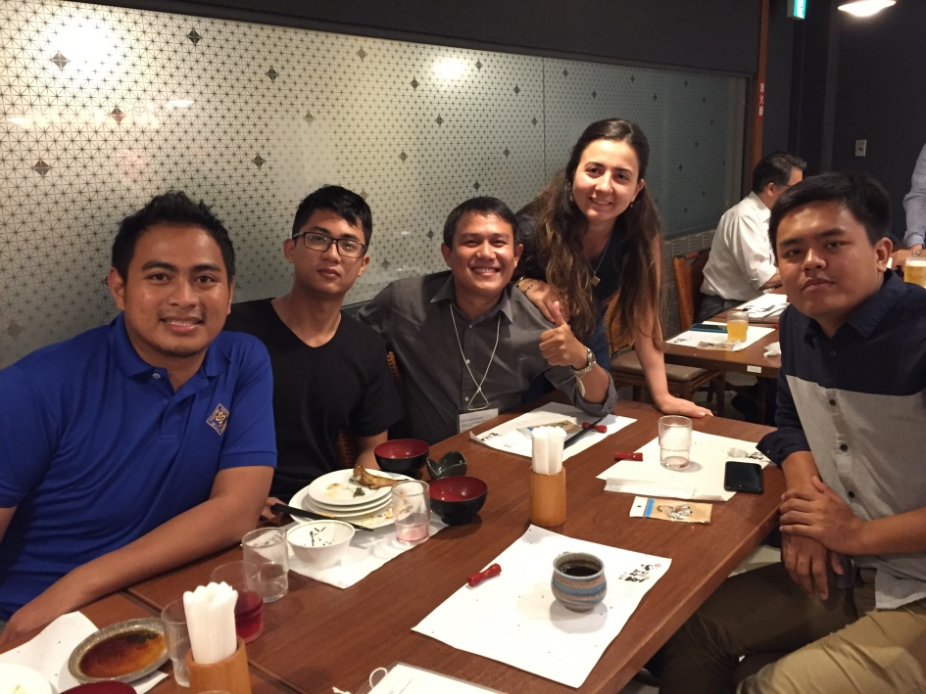
Figure 37 A delicious meal with JSCE

At the end of the party, we took our last group photos and said goodbye to Mr. Arai, Ms. Shibuya and Mr. Katayama. After that, Mr. Yoshizawa and Mr. Katayama took us back to the hotel. We gave other the best wishes, shook hands for the last time and said goodbye. Throughout the trip, they took care of us and taught us a lot, hence I felt really sad when I had to say “goodbye, see you in the future”.
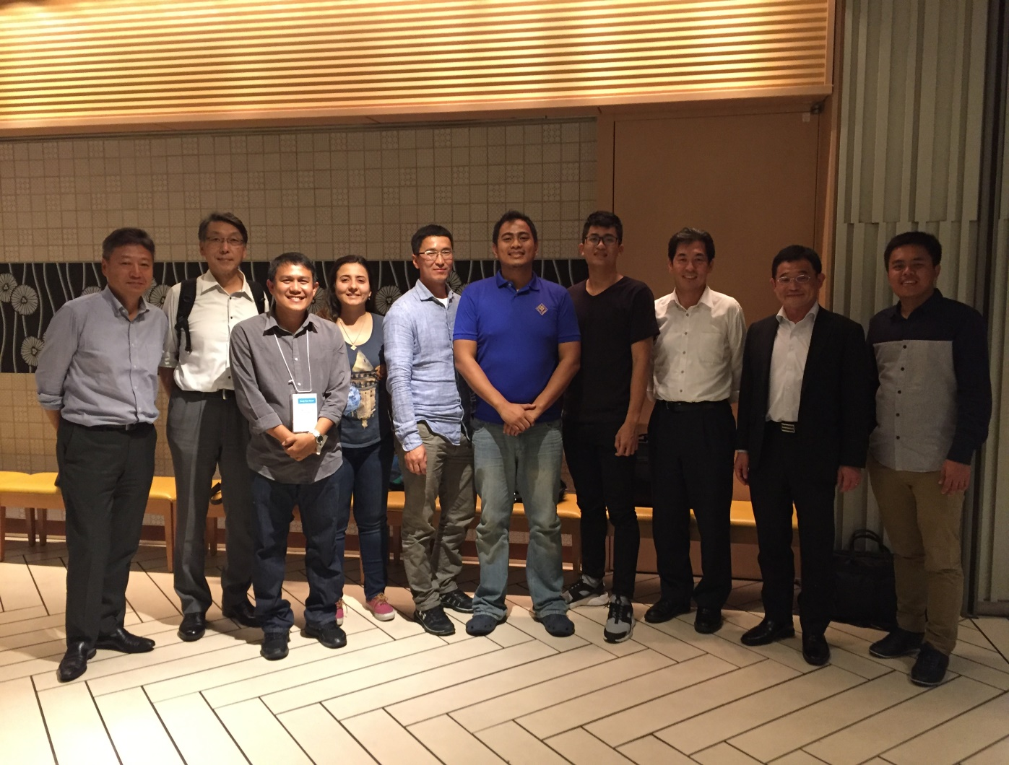
Figure 38 Thank you JSCE!!!

2.6 The 6th day (15th September)
At noon, Mr. Arai, Ms. Suzuki came to pick us up at noon to go sightseeing in Tokyo. This was a quite interesting experience because we used the metro system and a boat – my “river bus” to travel around the city. Our first destination was the Asakusa Kannon Temple. Firstly, we freely went shopping on Nakamise road. When we gathered at the main hall, I tried my luck with Omikuji Paper Fortune and surprisingly, I got daikichi-the best fortune.
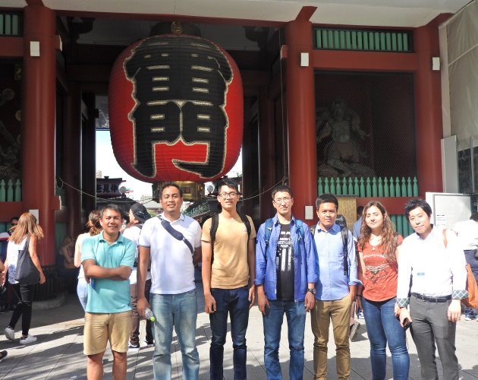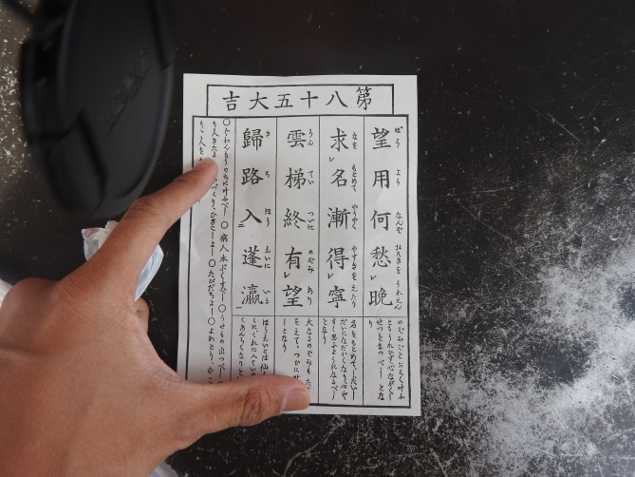
Figure 39 At Asakusa Kannon Temple Figure 40 Daikichi

After that, we came into the Main Temple-Kannondo, gave away our coins and prayed for luck.
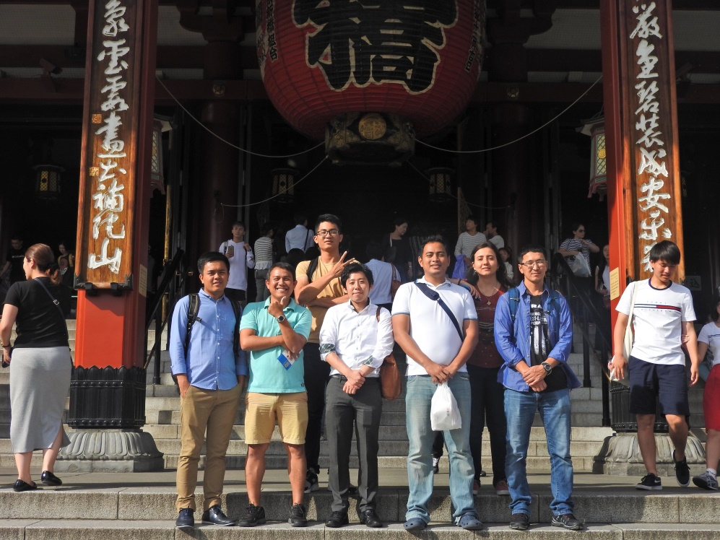
Figure 41 Group photo at Kannondo

Our next stop was Tokyo Sky Tree. The scenario of Tokyo from the top of Tokyo Sky Tree was breathtaking. After 2 hours going around the building, we took a train to get back to the hotel.
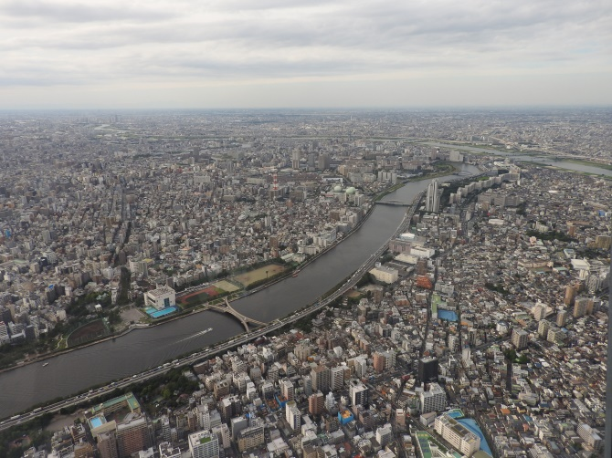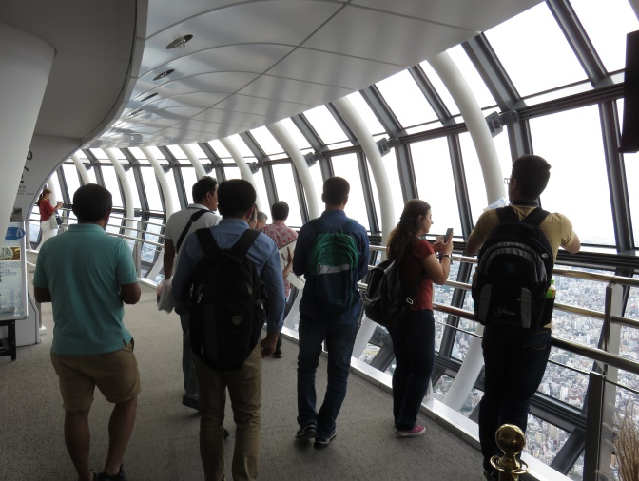
Figure 42 Tokyo view Figure 43 Sightseeing in Tokyo Sky Tree

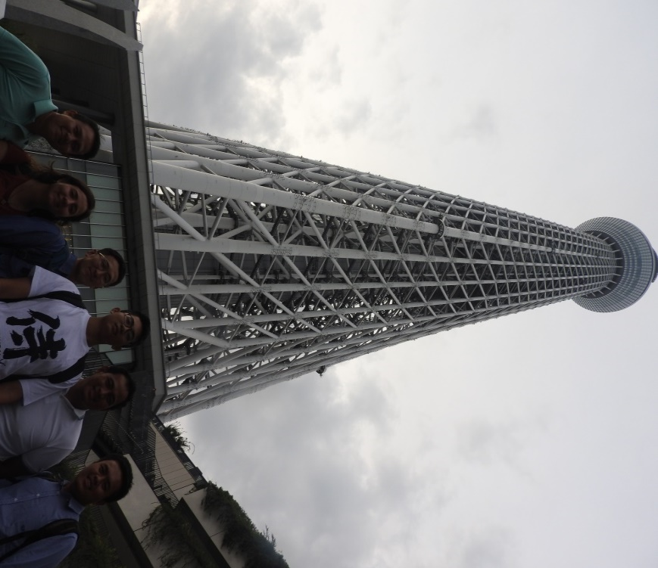
Figure 44 Group photo under Tokyo Sky Tree

When we got there, we took pictures, said goodbye to Mr. Arai and went for dinner together. At night, we had a traditional Japanese meal and enjoyed our last night together in Tokyo. After that, we returned to the hotel, took pictures, said goodbye to the others and prepared for our upcoming flights.
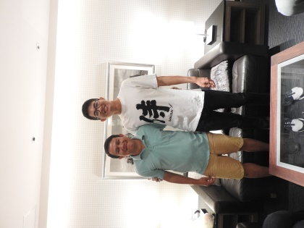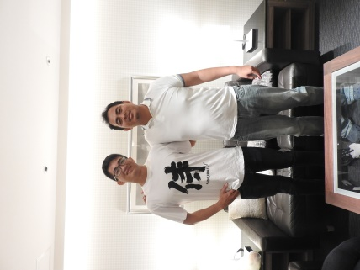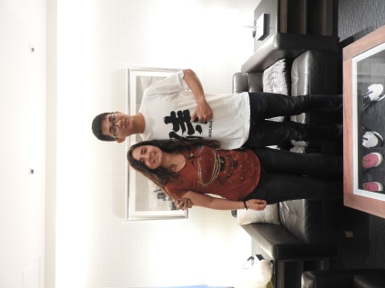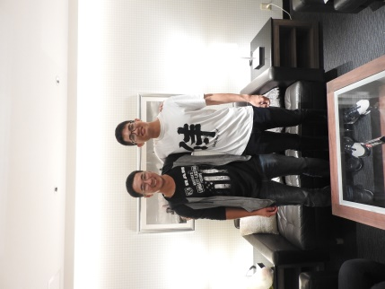
Figure 45, 46, 47, 48 Goodbye my friends!

2.7 The 7th day (16th September)
My flight started at 3pm and Ms. Suzuki helped me to go to the airport. I had a comfortable flight and returned to Tan Son Nhat Airport safely. Everything was perfect and I finished my Study Tour Grand successfully.

3. GRATITUDE AND ACCOMPLISHMENT
First of all, I would like to express my gratitude to Japan Society of Civil Engineering for giving me this opportunity. Moreover, my special thanks are sent to Mr. Yoshizawa, Mr. Katayama for taking care of me and widening my comprehension. Also, I would like to give the most sincere thanks to Ms. Shibuya, Mr. Arai and all the JSCE staff who had been always caring and willing to help me accomplish Study Tour Grand.
At the same time, I would like to express my gratitude to my professor Mr. Tung for nominating me. Thank you for encouraging me all the time and helping me to complete my application and my research. Also, I want to send a sincere thanks to my advisor Dr. Mikio Ishiwatari for giving lots of valuable advice and helping me to complete my research.
For the STG program, this trip gives me lots of knowledge as well as experience. Throughout the field trips at 4 of the biggest Japanese construction company, I acknowledge lots of advanced, modern technology and learned how to apply it. The most memorable moment for me is my presentation at the 19th International Summer Symposium. This has been the my first time ever to present a research at an international conference and although I felt extremely nervous, I successfully delivered my presentation. Moreover, STG is not only about learning new technologies, it is also a rare opportunity to meet civil engineers from different countries and we truly had an unforgettable time together.
Lastly, this study tour really inspires me a lot. Currently, I am working on a scientific research on one of the projects at the 19th International Summer Symposium and writing a scientific paper to introduce this program in my university.
To sum up, my Study Tour Grand was successfully completed and one last time,
THANK YOU SO MUCH EVERYONE, I WILL COMEBACK JAPAN IN THE FUTURE!!!

